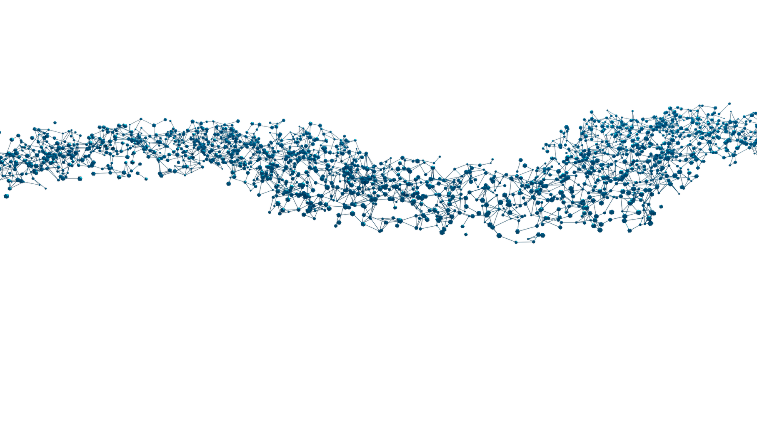

MERCURIUS™

DRUG-seq Service
(Frozen cell pellet)

Sample Preparation and
Submission Guidelines

RNA Extraction-free Protocol for
96- and 384-well Plate Format

December 2025

v.0.2.1. October 2023

DRUG-seq Service for 96- and 384-well Plate Format

Sample submission guidelines at a glance
- Prepare the samples as described and store them at -80°C prior to shipment.
- Fill the Sample Submission Form (SSF) and check all the boxes in the Sample Submission Checklist below; send both files to orders@alitheagenomics.com. Please be aware that any inconsistencies may result in delays or additional fees.
- Request the shipping address from your sales specialist.
- Ship the samples on dry ice, ensuring the plates are placed between layers of dry ice to maintain a consistent freezing temperature throughout transit. Please provide us with the shipment tracking number.

Sample Submission Checklist
- The Sample Submission Form (SSF) must be filled out correctly with a unique sample ID. Consider adding a suffix for technical replicates (e.g., XX_rep1, XX_rep2, etc.). Ensure that the SSF provides information about all the shipped samples.
- Avoid having randomly distributed samples across the plate layout (e.g., in A01, A06, B03, G10-12, etc.).
- The minimum number of samples in each group (to be pooled together) is 16 (for a 96-well plate) and 150 (for a 384-well plate).
- One type of seeded cell per well, with only one type of cell pooled together, and a minimum of 80’000 cells per pool.
- Plates are labeled with the same Plate ID as indicated in the SSF.
- Plates are well sealed with an adhesive and a temperature-resistant seal (aluminium is ideal).

Required consumables (not provided)
Reagents | Manufacturer | PN
DPBS, no calcium, no magnesium | Gibco | 14190144
Aluseal, adhesive aluminum seal for the cell plate | Thermo | AB0626

Essential considerations for input material

The recommended input range of cells is:
- 15000-50000 cells per well for a 96-well plate;
- 2000-10000 cells per well of a 384-well plate.
However, this number can vary depending on the cell type, size, and mortality/viability of cells after the treatment.
  - For the best protocol performance, the cells should be 90% confluent on the day of cell collection.
  - Cells must be seeded several days in advance for optimal results.
1.4 Depending on the type of cells (human, mouse, cancer, or primary) and the experimental design (e.g., drug treatment, induction of apoptosis, cell cycle arrest, etc.), consider the cell doubling time after seeding and the potential effect of the treatment on cell quality and quantity.
1.5 To ensure an even distribution of reads after sequencing, the amount of starting material must be as uniform as possible. For this, we suggest using automated cell seeding instruments or double-verified cell counts.

Cell Pellets Preparation Protocol

2.1. Procedure for the preparation of adherent cells
    - Seed the cells in a flat-bottom 96- or 384-well plate at a density that will enable harvesting enough cells (see p.1.1).
    - On the day of cell pellet preparation, gently aspirate the culture media from the plate and wash the cells by adding room-temperature DPBS:
- 80-100 µL per well (for 96-well plate)
- 30-50 µL per well (for 384-well plate)
    - Gently tap the plate and aspirate as much DPBS as possible without disturbing the cells.
    - Seal the plate well with an Aluseal and immediately transfer it to a -80°C freezer for storage. If possible, snap-freeze the plate with dry ice beforehand.

2.2. Procedure for the preparation of suspension cells
    - Seed the cells in a U-shaped 96- or 384-well plate at a density that will enable harvesting enough cells (see p.1.1).
2.2.2. On the day of cell pellet preparation, centrifuge the plate at 300x g for 5 min.
2.2.3. Gently aspirate the culture media from the plate and wash the cells by adding a room-temperature DPBS:
- 80-100 µL per well (for 96-well plate)
- 30-50 µL per well (for 384-well plate)
    - Gently tap the plate and centrifuge it at 300x g for 5 min. Aspirate as much DPBS as possible without disturbing the cells.
    - Seal the plate well with an Aluseal and immediately transfer it to a -80°C freezer for storage. If possible, snap-freeze the plate with dry ice beforehand.
NOTE: If several plates must be processed, perform the procedure individually per plate to avoid keeping the plates at room temperature for a prolonged time.

