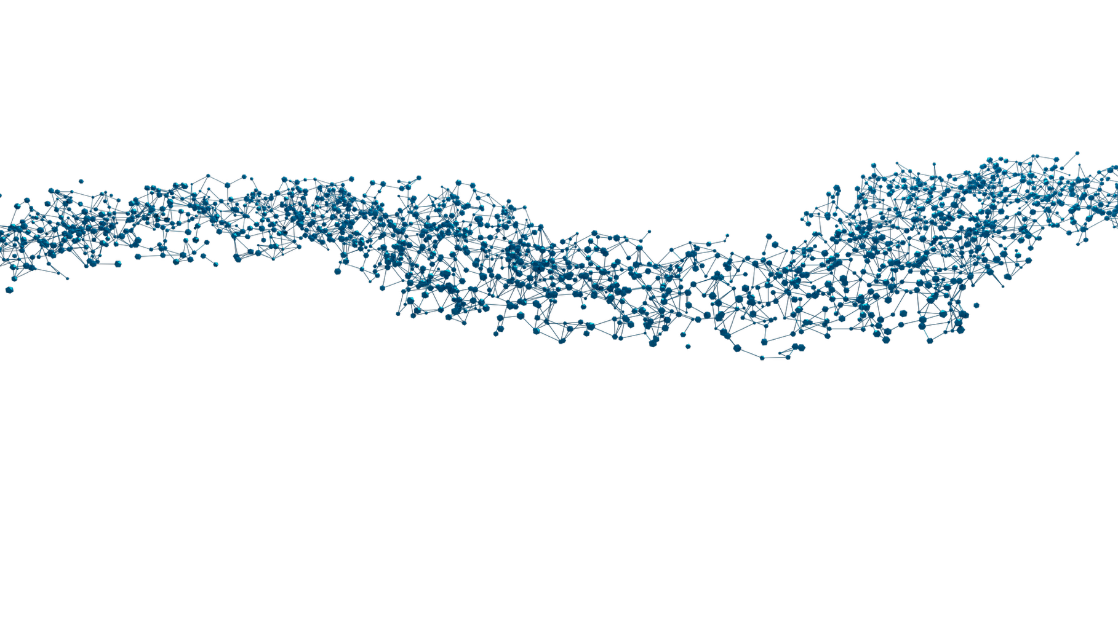

DRUG-seq Service
(Lysate preparation)

Sample Preparation and
Submission Guidelines

RNA Extraction-free Protocol for
96- and 384-well Plate Format

November 2025

v.0.2.1. October 2023

MERCURIUS™

DRUG-seq Service for 96- and 384-well Plate Format

Sample submission guidelines at a glance
- Prepare the samples as described and store them at -80°C prior to shipment.
- Fill the Sample Submission Form (SSF) and check all the boxes in the Sample Submission Checklist below; send both files to orders@alitheagenomics.com. Please be aware that any inconsistencies may result in delays or additional fees.
- Request the shipping address from your sales specialist.
- Ship the samples on dry ice, ensuring the plates are placed between layers of dry ice to maintain a consistent freezing temperature throughout transit. Please provide us with the shipment tracking number.

Sample Submission Checklist
- The Sample Submission Form (SSF) must be filled out correctly with a unique sample ID. Consider adding a suffix for technical replicates (e.g., XX_rep1, XX_rep2, etc.). Ensure that the SSF provides information about all the shipped samples.
- Avoid having randomly distributed samples across the plate layout (e.g., in A01, A06, B03, G10-12, etc.).
- The provided volume should be uniform in all wells.
- The minimum number of samples in each group (to be pooled together) is 16 (for a 96-well plate) and 150 (for a 384-well plate).
- One type of seeded cell per well, with only one type of cell pooled together, and a minimum of 80’000 cells per pool.
- Plates are labeled with the same Plate ID as indicated in the SSF.
- Plates are well sealed with an adhesive and a temperature-resistant seal (aluminium is ideal).

Consumables provided
Component name | Label | Volume, µL |  | Storage
Component name | Label | 96WP | 384WP | Storage
Cell Lysis Buffer | CLB | 710 | 2x 1500 | -20°C
RNase Inhibitor | INH | 175 | 2x 375 | -20°C

Required consumables (not provided)
Reagents | Manufacturer | PN
DPBS, no calcium, no magnesium | Gibco | 14190144
Aluseal, adhesive aluminum seal for the cell plate | Thermo Fisher | AB0626

Essential considerations for input cells
  - The recommended input range of cells is 15000-50000 cells/well of 96WP and 2000-10000 cells/well of 384WP.
  - Cells must be seeded a few days in advance for the best results.
  - Depending on the type of cells (human, mouse, cancer, or primary cells) and experimental design (e.g., induction of differentiation or apoptosis, cell cycle arrest, etc.), consider the doubling time of cells after the seeding and the potential effect of the treatment on the cell number during the experiment.
  - To ensure an even distribution of reads after sequencing, the amount of starting material must be as uniform as possible. For this, we suggest using automated cell seeding instruments or double-verified cell counts.

Cell pellets preparation protocol

2.1. Procedure for the preparation of adherent cells
2.1.1 Seed the cells in a flat-bottom 96WP or 384WP at the density that will enable harvesting (per well):
- 96WP: 15000-50000 cells
- 384WP: 2000-10000 cells
2.1.2 Gently aspirate culture media from the plate and wash cells by adding the DPBS in each well:
- 96WP: 80-100 µL
- 384WP: 30-50 µL
2.1.3 Gently tap the plate and aspirate as much DPBS as possible without disturbing the cell pellet.
2.1.4 Seal the plate and snap-freeze it on dry ice or liquid nitrogen for at least 5 min. Alternatively, the plate can be stored at -80°C for a few weeks.
2.1.5 Proceed to step 2.3 for cell lysis.

2.2. Procedure for the preparation of suspension cells
2.2.1 Seed the cells in a flat-bottom or U-shaped 96WP or 384WP at the density that will enable harvesting (per well):
    - 96WP: 15000-50000 cells
    - 384WP: 2000-10000 cells
2.2.2 Centrifuge the plate at 300x g for 5 min.
2.2.3 Gently aspirate culture media from the plate without disturbing the cell pellet, and wash cells by adding DPBS in each well:
- 96WP: 80-100 µL
- 384WP: 30-50 µL
2.2.4 Centrifuge the plate at 300x g for 5 min.
2.2.5 Gently tap the plate and aspirate as much DPBS as possible without disturbing the cell pellet
2.2.6 Seal the plate and snap-freeze it on dry ice or liquid nitrogen for at least 5 minutes. Alternatively, the plate can be stored at -80°C for a few weeks.
2.2.7 Proceed to step 2.3 for cell lysis.

2.3 Procedure for cell lysis
2.3.1 Prepare a working solution of 1x Cell Lysis Buffer with RNase Inhibitor (with 10% excess) as follows:

Reagent | 96WP, µL |  | 384WP, µL
Reagent | Per well | 96 wells | Per well | 384 wells
CLB | 6.6 | 700 | 5 | 2125
INH | 1.6 | 170 | 1.2 | 510
Water | 11.8 | 1250 | 8.8 | 3740
TOTAL | 20 | 2120 | 15 | 6375

2.3.2 Pipette a prepared mix gently a few times and briefly spin the tube. Keep the mix on ice until further use
2.3.3 Using a multi-dispenser, distribute the prepared 1x CLB in every well.
- 96WP: 20 µL per well
- 384WP: 15 µL per well
2.3.4 Centrifuge the plate at 300x g for 1 min to ensure that 1xCLB is uniformly distributed on the surface of each well.
2.3.5 Incubate the plate at room temperature for 15 min.
2.3.6 Transfer the lysate from every well to the corresponding well of the new 96- or 384-well PCR plate. Ensure proper labelling for easy identification during subsequent use.
2.3.7 Seal the plate with the aluminium seal and briefly spin it down.
2.3.8 The cleared lysates can be used directly for library preparation or safely stored at -80°C.
NOTE: If several plates must be processed, perform the procedure individually per plate to avoid keeping the plates at room temperature for a prolonged time.

